Assignment 2
1. Grade Checker
Take a score as input and print the grade based on the following:
- 90+ : “A”
- 80–89 : “B”
- 70–79 : “C”
- 60–69 : “D”
- Below 60 : “F”
- Use a basic if / else statement to determine the grade.
Code:
score_input = input("Enter your score: ").strip().lower()

if score_input == "90+" or score_input.startswith("90"):
print("Grade: A")

elif score_input in ["80-89", "80-90"] or (score_input.isdigit() and 80 <= int(score_input) <= 89):
print("Grade: B")

elif score_input in ["70-79"] or (score_input.isdigit() and 70 <= int(score_input) <= 79):
print("Grade: C")

elif score_input in ["60-69"] or (score_input.isdigit() and 60 <= int(score_input) <= 69):
print("Grade: D")

elif score_input in ["below 60", "below60", "<60"] or (score_input.isdigit() and int(score_input) < 60):
print("Grade: F")

else:
# Try to treat it as a pure number
try:
score = int(score_input)
if score >= 90:
print("Grade: A")
elif score >= 80:
print("Grade: B")
elif score >= 70:
print("Grade: C")
elif score >= 60:
print("Grade: D")
else:
print("Grade: F")
except:
print("Invalid input! Please enter something like 90+, 80-89, 75, or 45")
Output: 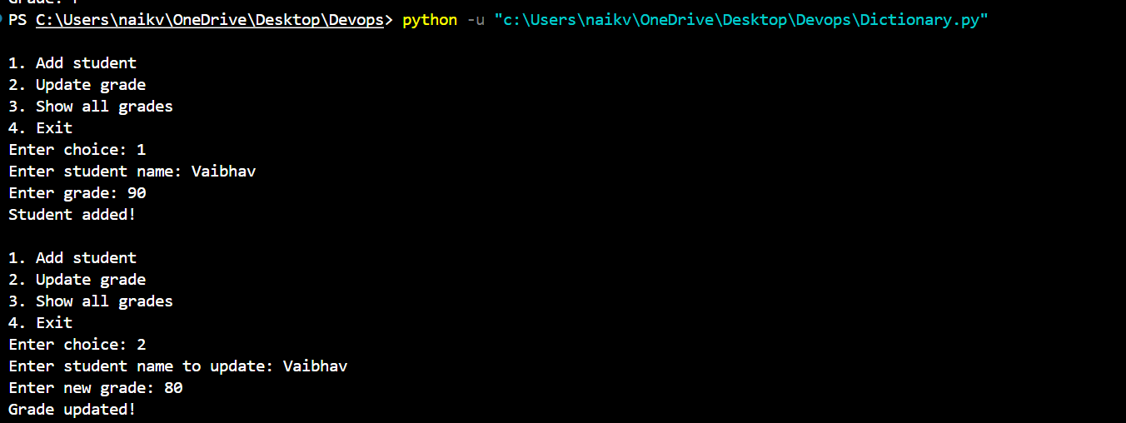
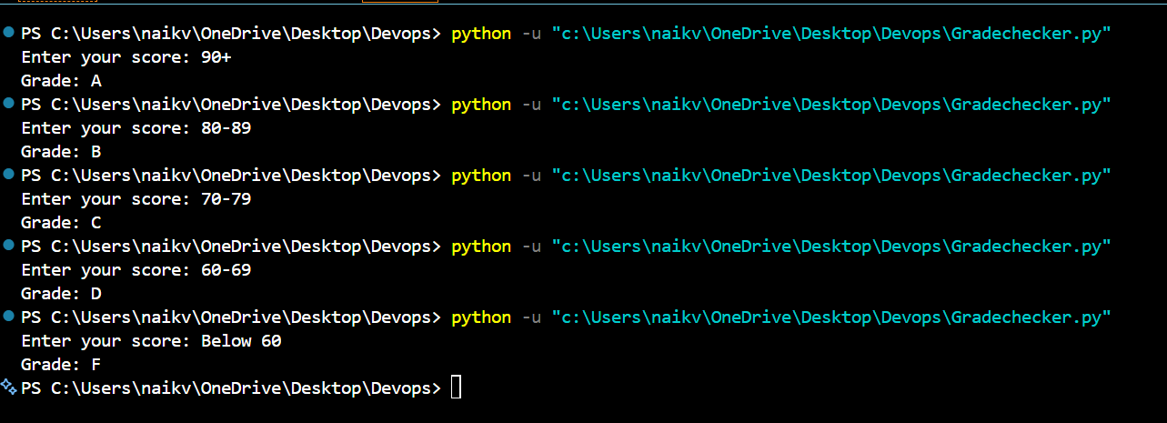
Explanation:
This program takes a student's score as input and checks it using if, elif, and else conditions. Based on the score, it prints the corresponding grade from A to F.

2. Student Grades
Create a dictionary where the keys are student names and the values are their grades. Allow the user to:
- Add a new student and grade.
- Update an existing student's grade.
- Print all student grades.
- Use a dictionary and basic operations with if / else.

Code:
students = {
"Rahul": "A",
"Priya": "B",
"Amit": "C"
}

name = input("Enter student name: ")
grade = input("Enter grade: ")

if name in students:
students[name] = grade
print("Student grade updated successfully.")
else:
students[name] = grade
print("New student added successfully.")

print("\nStudent Grades:")

for student, grade in students.items():
print(student, ":", grade)

Output: 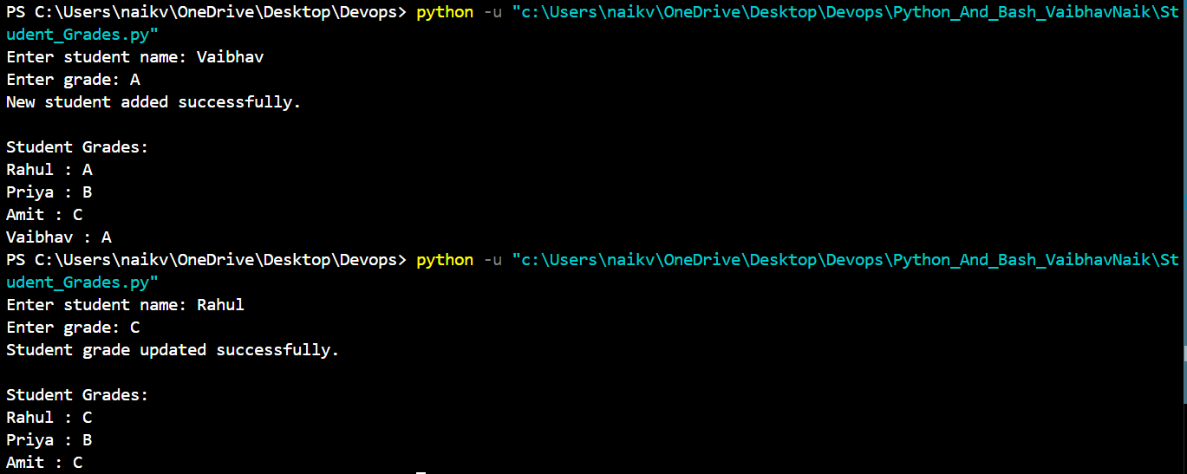
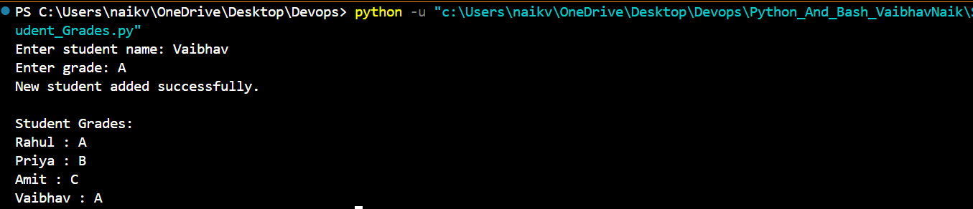

Explanation:
This program uses a dictionary to store student names and their grades. The user can enter a student name and grade. If the student already exists, their grade is updated. If the student is not present, a new student is added. Finally, the program displays all the student grades.

3. Write to a File
Write a program to create a text file and write some content to it, using file functions like open() and write().

Code:
file = open("student.txt", "w")

file.write("Student Name: Vaibhav\n")
file.write("Course: Computer Engineering\n")
file.write("This file was created using Python.")

file.close()

print("Content written to the file successfully.")

Output:
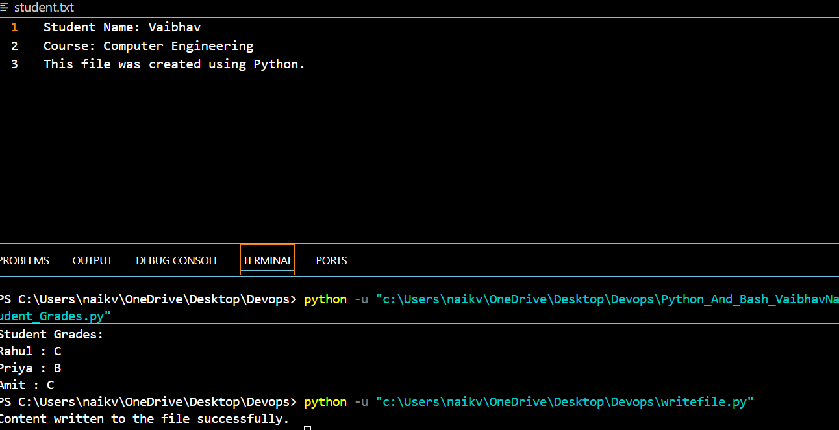
Explanation:
This program creates a text file named student.txt using open() in write mode. The write() function is used to add content to the file. Finally, close() is used to close the file.

4. Read from a File
Open the file in read mode and use file.read() to read and display its content.
Code:
file = open("student.txt", "r")

content = file.read()

print("File Content:")
print(content)

file.close()

Output:
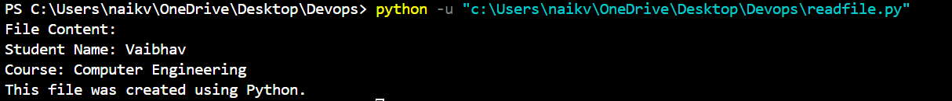

Explanation:
This program opens the student.txt file in read mode using "r". The read() function reads the complete content of the file and displays it on the screen. After reading the file, close() is used to close it.

Github: https://github.com/Bobooo404/Devops.

